Exercise 4 : Git-HOL (Git Merge Conflict Resolution)

1 ) Creating GitWork Branch and Modifying hello.xml

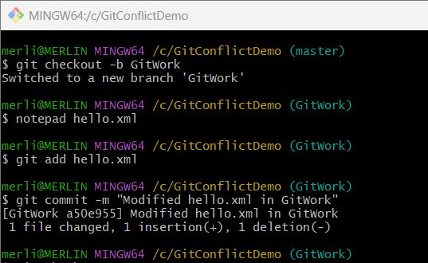

2) Switching to Master Branch and Creating Merge Conflict

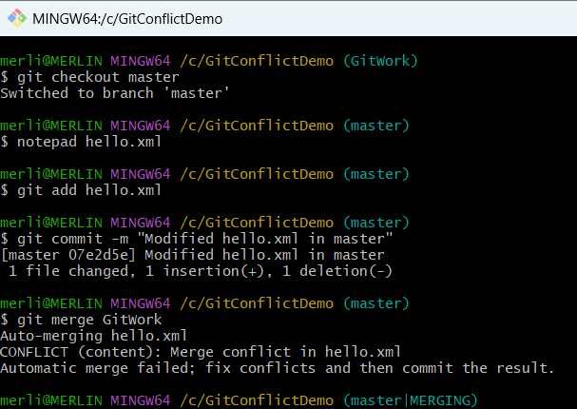

3) Merge Conflict Markers in hello.xml

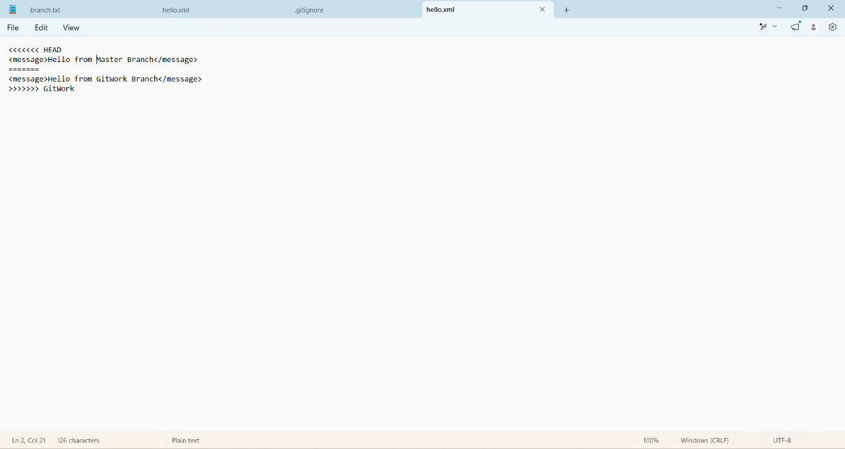

4) Resolving the Merge Conflict

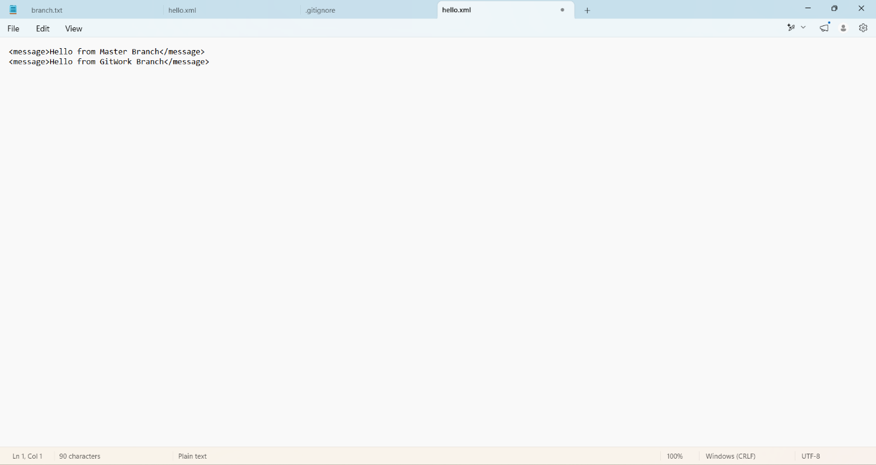

5) Verifying Repository Status

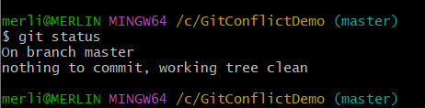

6)Creating and Committing .gitignore

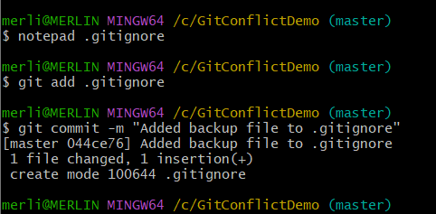

7) Listing and Deleting the Merged Branch
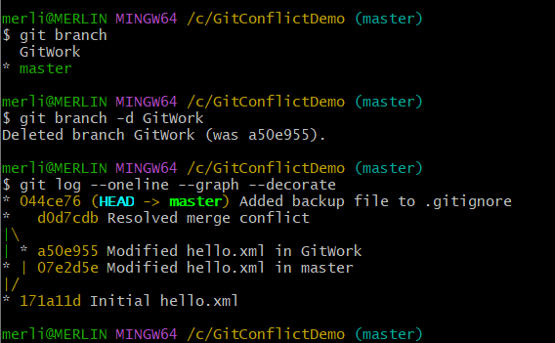

8) Final Git Commit History



